Sprint Retrospective – 26.04

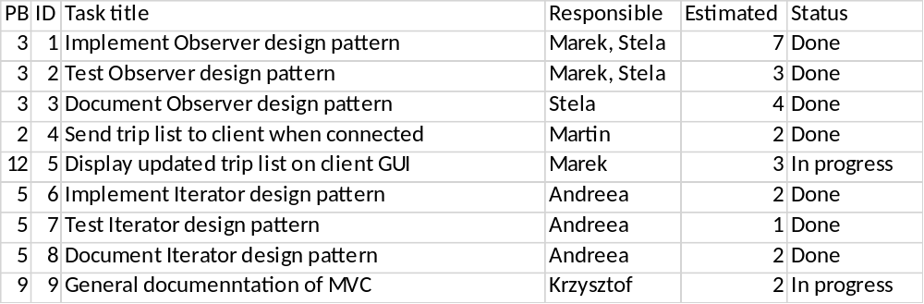

The observer design pattern was fully implemented. By comparing observer classes in our project with the official ones we came to conclusion that the observer design pattern was designed and implemented properly. Documentation for observer was also finished. After connecting client to server, the current trip list form the server is sent to client. The implementation for showing new trip list after creating new trip on server has started. Iterator design pattern has been implemented, tested and documented. Documentation for MVC design pattern was created and started.

